**Enhancement One: Software Design/Engineering**

The artifact I selected is the Travlr Getaways Travel Booking Website, originally developed as part of the CS465 Full Stack Development course. This project is a comprehensive web application that allows users to browse and book travel packages. It includes features for user authentication, trip management, and booking functionalities.

I chose this artifact for my ePortfolio because it showcases my skills in both front-end and back-end development, as well as my ability to integrate various components into a cohesive application. The enhancements made to this project demonstrate my proficiency with modern web development frameworks, particularly Angular, and my understanding of modular, component-based architecture. This involved creating a new TripDetailsComponent to handle the display of individual trip details, which was previously managed within the TripCardComponent. This separation of concerns improved code modularity and maintainability. The TripCardComponent was updated to utilize the new TripDetailsComponent, simplifying its role to a higher-level component that delegates specific tasks to dedicated components. Additionally, a shared module (SharedModule) was created to handle shared components and services, enabling efficient dependency injection across the application. The TripDataService and AuthenticationService were updated to use Angular's dependency injection, promoting cleaner and more maintainable code.

The primary course objective with this enhancement is the demonstration of innovative techniques and tools in software engineering and design. By refactoring the code to use a component-based architecture, I have improved the maintainability and scalability of the application. This aligns with the course outcomes of designing computing solutions using best practices and managing trade-offs in design choices.

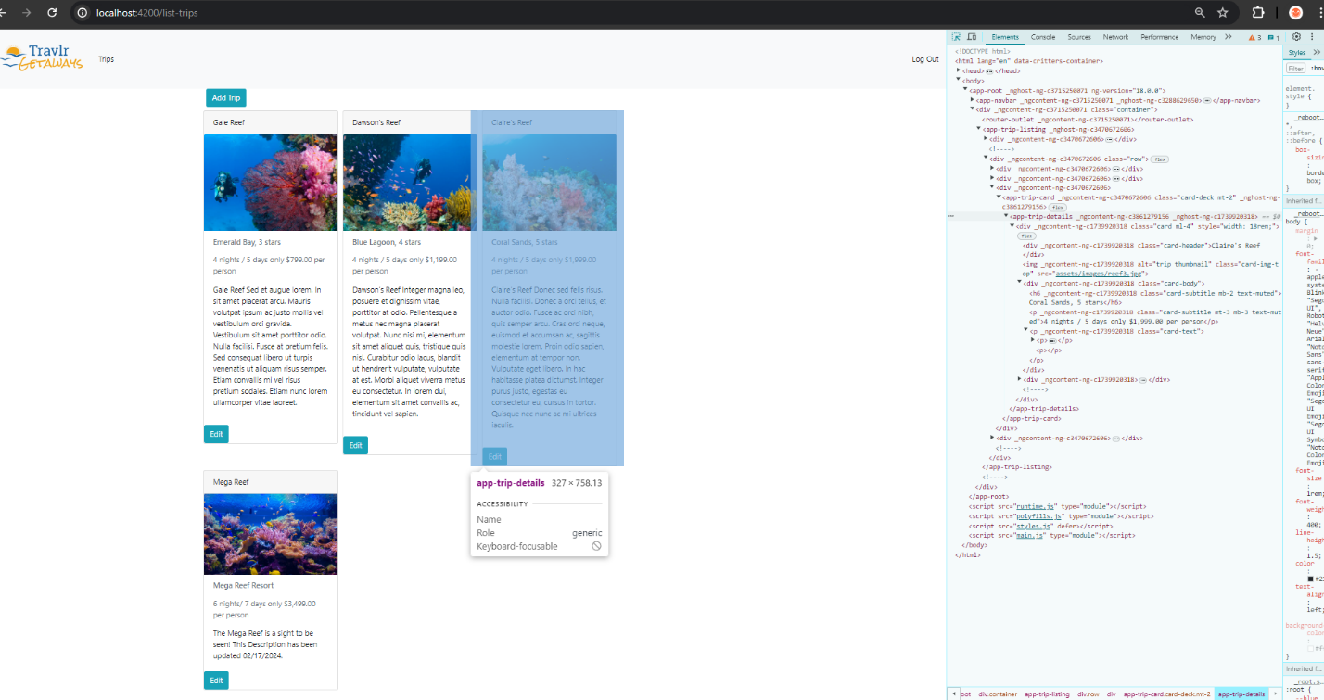During the enhancement process, I learned more about the importance of modular design in improving code readability and maintainability. One challenge I faced was ensuring seamless interaction between the new components and existing services. This required a solid understanding of Angular's dependency injection and service management. This enhancement not only improved the functionality and maintainability of the Travlr Getaways Travel Booking Website but also reinforced my skills in software design and engineering. It exemplifies my ability to implement advanced front-end development techniques and create scalable web applications.